**DevOps Process Flowchart: A Visual Journey**

While the specifics of a DevOps process might vary depending on the organization and technology stack, here's a general flowchart visualizing the key stages:

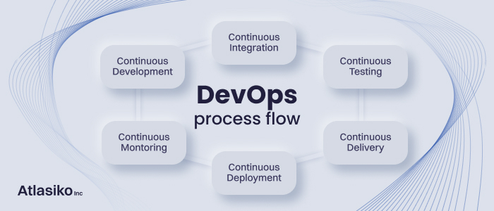

**1. Plan:**

* **Requirements and Design:** Stakeholders, analysts, and developers gather requirements, design, and architecture the solution.
* **Version Control:** Code, scripts, and configurations are stored in a centralized repository like Git for tracking and collaboration.

**2. Develop:**

* **Development:** Developers write, test, and commit code changes frequently in small, manageable units.
* **Continuous Integration (CI):** Each commit triggers automated builds, tests, and static analysis, catching issues early.
* **Peer Reviews:** Developers review each other's code, fostering knowledge sharing and code quality.

**3. Test:**

* **Unit Testing:** Developers write automated tests for individual units of code, ensuring their functionality.
* **Integration Testing:** Tests ensure different code modules work together seamlessly.
* **Automated Testing:** A suite of automated tests covers various scenarios, promoting consistent and fast feedback.

**4. Deploy:**

* **Continuous Delivery (CD):** Automated pipelines deploy code changes to test and production environments efficiently.
* **Infrastructure as Code (IaC):** Infrastructure configurations are managed as code, ensuring consistency and repeatability.
* **Blue-Green/Canary deployments:** New versions are rolled out gradually, minimizing risk and downtime.

**5. Monitor & Operate:**

* **Monitoring and Logging:** Continuous monitoring tracks application health, performance, and user behavior.
* **Alerting and Escalation:** Issues are automatically detected and communicated to responsible teams for prompt resolution.
* **Feedback and Iteration:** Metrics and user feedback inform future development and improvement cycles.

**Explanation of Each Stage:**

* **Plan:** This stage establishes the foundation for the project, clearly defining goals and ensuring everyone is on the same page.
* **Develop:** This stage focuses on code quality and building the solution incrementally with continuous feedback loops.
* **Test:** This stage involves rigorous testing at various levels to ensure functionality, integration, and reliability.
* **Deploy:** This stage automates deployments, ensures infrastructure consistency, and minimizes downtime during releases.
* **Monitor & Operate:** This stage proactively identifies and resolves issues, optimizes performance, and gathers feedback for continuous improvement.

**Remember:** This is a simplified representation, and the specific tools and technologies used may vary depending on the organization's needs and preferences. Additionally, the process is cyclical, with feedback informing future planning and development.